|  |
| --- |
| EPPS 6356-Data Visualization |
| Final Project Report-Wage Trends by Sectors among China, U.S. and Canada |
| Instructor: Karl Ho |

|  |
| --- |
| Yuming Wang  2020-12-01 |

**Background**

In the last decade, the world's economy has developed rapidly and people's wages have also risen. “Wages earnings is an important income for people and families and employees are expected to have wage increase to raise their living standards” (Congressional Research Service). The wage level of a country plays an important role for the stable development and prosperity of a country. For example, for many international students, their career and personal development are highly depending on where to work after graduation. They may always struggle to decide whether to go back to their own country or to work in another country. Therefore, studying and comparing country's growth rate can help them make better decisions. In the other hand, studying the growth rate of wages in each country will give people an idea of the growth of each country, for the growth rate of wages in a certain extent indicates the overall development of the country.

**Research Statement**

The research paper is studying how the workers’ wages grow differently in various sectors in last decade in different countries. Whether the growth rates appear similarly or have significant differences among different countries. Specifically, the study compares the differences of wages growth rate by sectors in US, Canada, and China. The ten sectors were chosen to compare are Average Wage, Mining, Manufacturing, Production and Supply of Electricity, Health, Gas and Water, Construction, Wholesale and Retail Trades, Transport Storage and Post, Information Transmission, Software and Information Technology, Financial Intermediation and Education. By comparing the wage growth rates of these different sectors, people can easily understand the wage growth of different sectors in different countries and the economic development and structure of each country.

**Data**

The data is collected the firsthand data from the official labor website of China, the United States and Canada. Next, these data are exported in Excel and calculated for growth rate for each sector. The ten sectors for each country are compared. They are Average Wage, Mining, Manufacturing, Production and Supply of Electricity, Health, Gas and Water, Construction, Wholesale and Retail Trades, Transport Storage and Post, Information Transmission, Software and Information Technology, Financial Intermediation and Education.

Figure 1-1 displays the China wage data from year 2009 to year 2018.

**Figure 1-1**

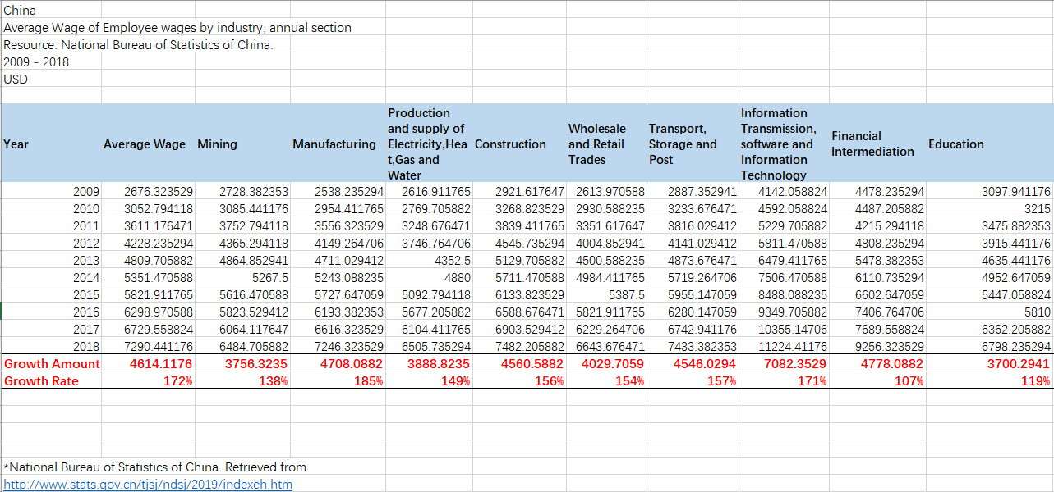

The U.S. wage data is collected from U.S. Bureau of Labor Statistics. Each sector’s growth rate is calculated in following figure 1-2:

**Figure 1-2**

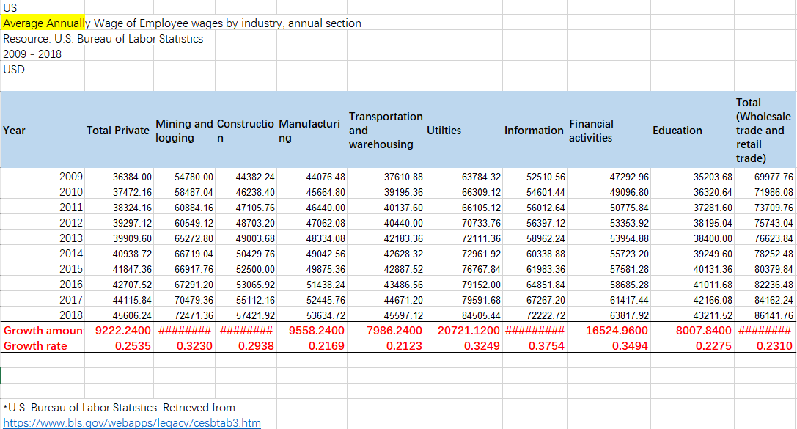

The Canada wages from year 2009 to 2018 are collected from Statistics Canada website and shows in the following figure 1-3:

**Figure 1-3**

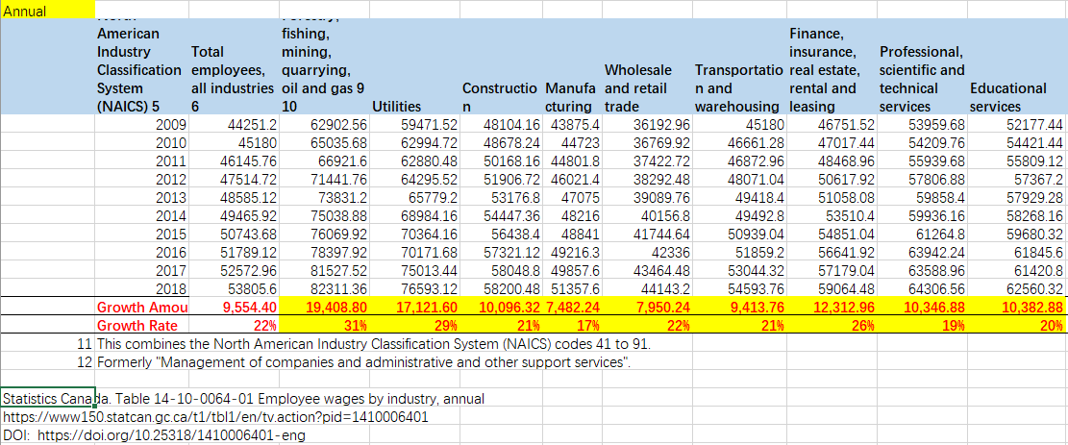

For the data visualization data, the growth rate is summarized in Excel and upload into R and Github. The figure 1-4 indicates the summarized data for each country.

**Figure 1-4**

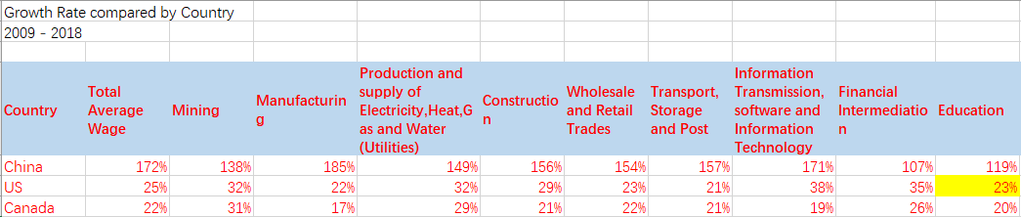

**Data Visualization Methods and Products**

The purpose of this project is to visually process the data that have been collected through programming and display the data through images. People would more intuitively see the changes of wages in various sectors in China, the United States, and Canada in the past ten years. In this project, the bar chart is built through R language, with X-axis representing each industry and Y-axis representing the growth rate of wages. The data of China, the United States, and Canada is put in a group and in each industry on the X-axis. By looking at this chart, people can clearly compare which countries have high or low growth rates for their corresponding sectors. In this program, the ggplot2 is used to create the bar chart. For the bar chart shows each data category in a frequency distribution, summarizes a large data set in visual form, estimates key values at a glance, and permits a visual check of the accuracy and reasonableness of calculations. The figure 2-1 shows the R program Code.

**Figure 2-1**

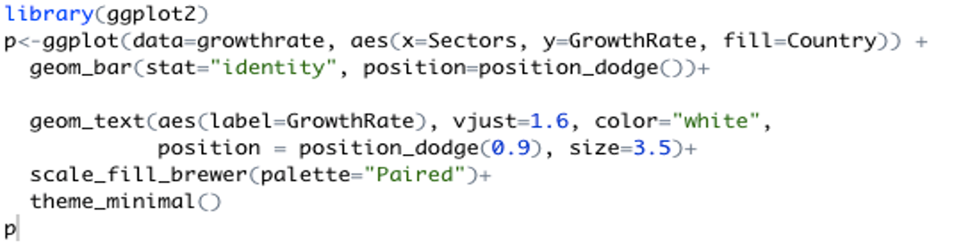

The figure 2-2 shows the bar chart product. In this product, it’s clearly see that Chinese wage’s growth rate is significantly higher than U.S. and Canada for every sector. And Canada and U.S. wage growth rate are displaying similar growth trend. For specifically, expect Mining and Transport, U.S. wage growth rate by each sector higher than Canada.

The figure 2-2 shows the bar chart product for this project.

**Figure 2-2**

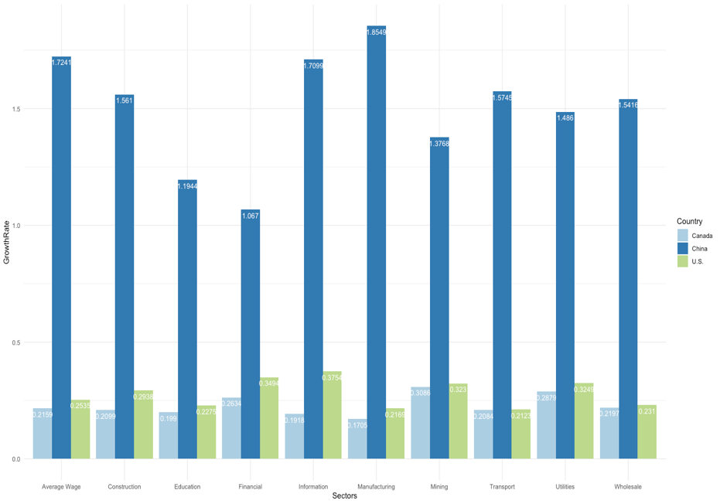

**Shiny App**

After completing the bar chart with R, Shiny App was made with R and Shiny is published it in My Github Page. Shiny is a great interactive development platform to connect R Studio, transmit data to each other, and display user wanted pages. The Bar Chart has moved to shiny App and the optional RadioButton was opened to discover the growth rates of countries by selecting the sectors needed.

A shiny app is also being made. The author downloads the package for Shiny and build the relationship between input and output. The data has been uploaded to Github from which the data could be downloaded directly from the Internet and many people could see instead of showing up on my computer. Secondly, the author built the basic framework for Shiny app, such as TextInput, Radiobuttons and caption. Afterwards, the author connects the data with Shiny app through Reactive function, so that with the author’s selection, the bar chart in Shiny app can change accordingly. Instead of using GGplot2 to make bar chart, the barplot () function was used, because in the construction of Shiny App, barplot () function was more efficient, while GGplot was more tedious and sometimes mistakes would be easily made. The figure2-3 shows the Shiny Code and figure 2-4 indicates the Shiny App. And the Github page URL is <https://yumingwang1.github.io/Data-visualization/>.

**Figure 2-3**

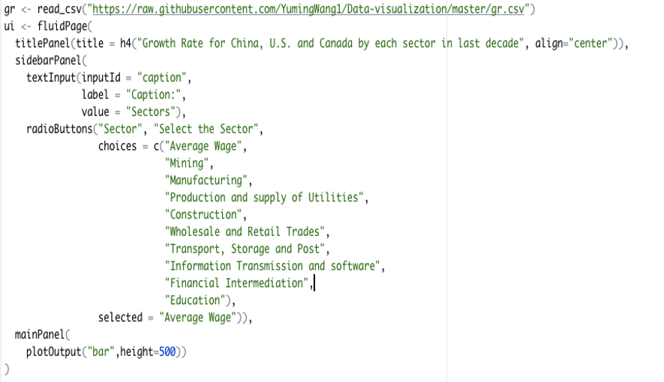



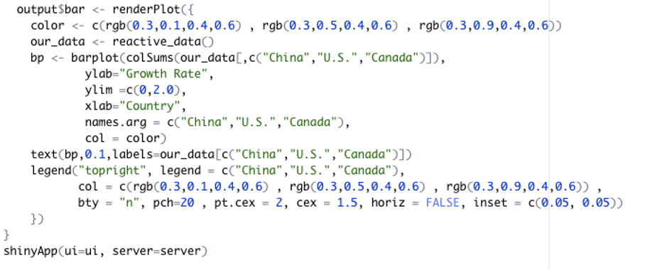

**Figure 2-4**

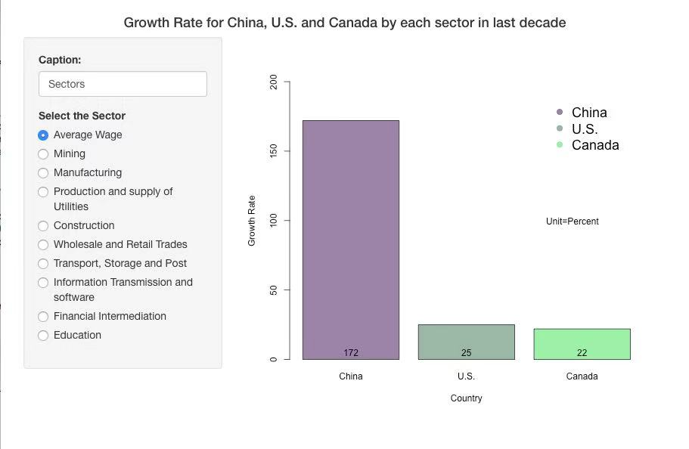

**Findings**

Here are some findings from the project. People can clearly see from the figure that the average wage growth rate of China is much higher than that of the United States and Canada. The reason may because China is a developing country and it is still developing continuously. The United States and Canada, on the other hand, are already in the part of the developed world. Their average wage is much higher than that of China, because they have been developing for many years. On the other hand, it can be seen from the side that the development of the United States and Canada has stagnated. In terms of wage growth across sectors, China is well ahead of the United States and Canada, with average wage growth already doubling in China. In the United States and Canada, however; growth rates across all sectors are clearly slow, with a typical rate of 20 to 30 percent. In addition, the growth rate of wages in various sectors in the United States is slightly higher than that in Canada but it does not show a large lead. So Canadian wages in this decade across sectors are not much different from those in the United States. In conclude, China's wage growth in recent years has been very high but it still struggles to match that of the United States and Canada in terms of wage volume. And China has been growing so fast in recent years that it may soon be able to catch up the wage levels in the United States and Canada.

In the Mining sector, wages have been growing at almost the same rate in the past decade in the United States and Canada, while in China it has increased by 137 percent. In the Manufacturing sector, the United States and Canada are almost the same, while China has achieved a growth rate of 185 percent. China is a Manufacturing country with dense population and developed cheaper labor force, which is also the reason why many factories are opened in China. In the Utilities sector, the United States is slightly above Canada. Among the sectors like Information, Financial Intermediation and Education, China’s growth lags far behind that of its manufacturing sectors. We can conclude that China's wage growth in technology, finance, and education is still falling short of expectations. Wage growth in the United States and Canada are slow but steady.

**Conclusion**

In conclusion, because China is a developing country and it has displayed the highest Wage Growth Rate in the last decade in every Sectors than Canada and the United States. There is little difference in wage growth between Canada and the United States. But U.S. wage growth rate by each sector is higher than that of Canada. Despite the high rate of wage growth rate in China, the wage level in China is significantly smaller than those of the U.S. and Canada. Moreover, from the Chart, in the manufacturing and mining sectors, the average wage of China is growing faster. But for sectors such as technology and finance, average wages have risen more slowly. In contrast to the United States and Canada, its sectors such as finance and technology have displayed higher wage growth. The reason of those differences is because the U.S and Canada’s wage systems are complete and social welfare are mature; while China is a developing country and its wage system has not been established and its social welfare has not been fully opened. Therefore, for China has a large population base, there is still a lot of space for growth in China's per capita wage. Through this data visualization project, people could understand that the changes of wage growth rate by each sector among China, U.S. and the Canada in the last decades. This project helps me see the changes of wage growth rate and know the structures in China, U.S., and Canada.

**Reference**

Congressional Research Service. July 23, 2019. Real Wage Trends, 1979 to 2018.

Retrieved from

<https://fas.org/sgp/crs/misc/R45090.pdf#:~:text=Other%20factors%20are%20likely%20to%20contribute%20to%20wage,institutions%2C%20workplace%20organization%20and%20practices%2C%20and%20macroeconomic%20trends>.

Information Satiation. March 12, 2018. Why Do Wage Rise? *Civic and Economic*

*Literacy, Minimum Wage.* Retrieved from <https://informationstation.org/video/why-do-wages-rise/>

National Bureau of Statistics of China. Retrieved from

<http://www.stats.gov.cn/tjsj/ndsj/2019/indexeh.htm>

Statistic Canada. Retrieved from

<https://www150.statcan.gc.ca/t1/tbl1/en/tv.action?pid=1410006401&pickMembers%5B0%5D=1.1&pickMembers%5B1%5D=2.3&pickMembers%5B2%5D=3.1&pickMembers%5B3%5D=5.1&pickMembers%5B4%5D=6.1&cubeTimeFrame.startYear=2005&cubeTimeFrame.endYear=2019&referencePeriods=20050101%2C20190101>

U.S. Bureau of Labor Statistics. Retrieved from

<https://www.bls.gov/webapps/legacy/cesbtab3.htm>

U.S. Bureau of Labor Statistics. Retrieved from

<https://www.bls.gov/oes/current/oes_nat.htm#25-0000>